**Publishing dashboards to Tableau Public**

When you publish your dashboard to Tableau Public, the data source(s) must be a Tableau data extract (.tde) file. We looked at creating this file in the *Packaging workbooks with data* recipe of this chapter. If you have multiple data connections, then you must repeat this process for each data connection.

In this example, we use small data files. Note, however, that your extract may not include more than 1 million rows when published to Tableau Public.

**How to do it…**

Perform the following steps to publish dashboards to Tableau Public:

1. Open a copy of the Chapter Eight workbook.
2. Navigate to **Server** | **Tableau Public** | **Save to Web As…**, as shown in the following screenshot:

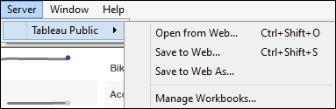

1. If you do not have an account already, then select the **Register** hyperlink and fill in the resulting form. The following screenshot shows the resulting form:

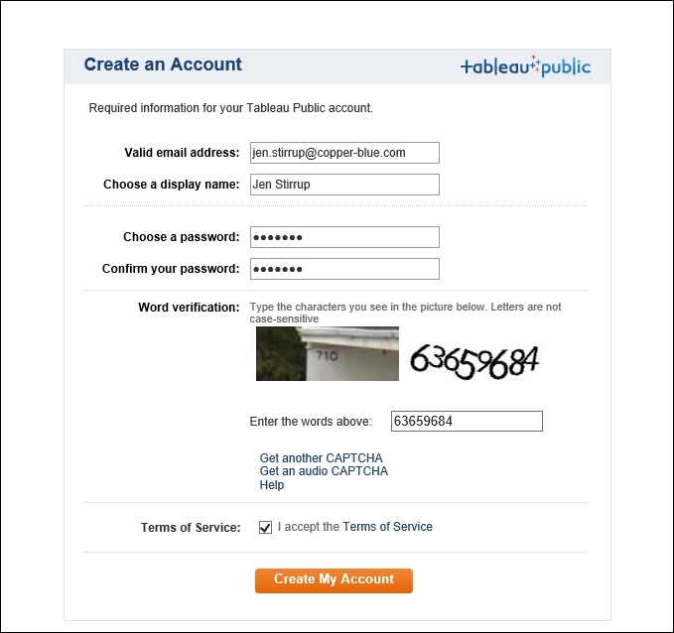

1. Once you have registered, you can log in. Here's the **Tableau Public Sign In** window:

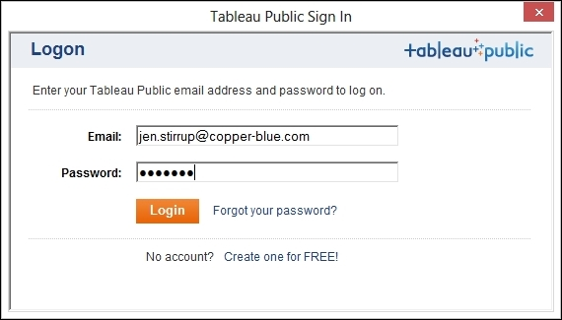

1. You will then get a dialog box named **Save Workbook to the Public Web** with the name of theworkbook in the **Name** field. Check the option **Show Sheets as Tabs** and then click on **Save**.
2. The file will start uploading, and you will see a small information box indicating the progress of the upload, as in the following screenshot:

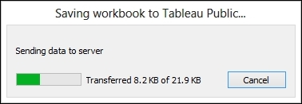

You will then see the resulting dashboard as follows:

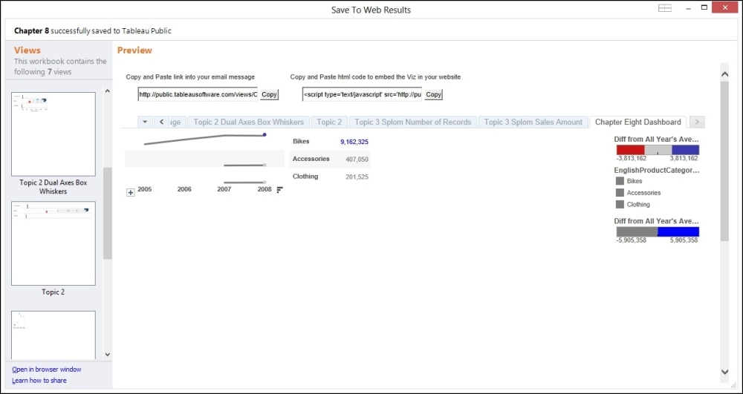

1. At the top of the page, you will see an option to embed the viz into your e-mail or website, as in the following screenshot:

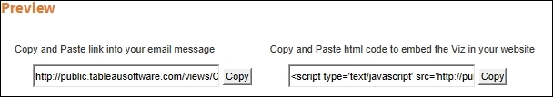

1. At the bottom of the page is the **Share** option. This allows you to control the size of the view and shows the toolbar to adjust size using the display options in the **Share** window.

You can change the width of the entire dashboard view when viewed in the browser. This option shows the current size by default. You can also change the height of the entire dashboard view when viewed in the browser. This option shows the current size by default.

1. If the **Show Toolbar** option is selected, the toolbar will appear along the bottom of the view.
2. Optionally, use the **URL for RSS links** option to add a URL that will be used as the link for static images in RSS feeds. For example, use this option to specify a destination page for the RSS entry rather than the main page of your blog or website. If you like, you can use this option to add tracking code to monitor traffic coming from your RSS feed.
3. Now you can share your visualization with the world!

**How it works…**

Tableau Public allows you to share your data visualizations with the world, but why would you want to share them?

In the words of The Guardian, "Data Journalism is the new punk." The central idea is that you can be a data citizen and use data to influence the world around you. You can question authority in an intellectual way, using data as a foundation.

However, data needs to be told in order to be understood, and data visualization is a way in which data citizens can spread the message. Tableau facilitates data citizens by offering Tableau Public, a free facility to spread the love of data. What's not to like?